**CS498 AMO - Homework 4**

Gassan Soukaev ([soukaev2@illinois.edu](mailto:soukaev2@illinois.edu))

Edgar Pino ([edgarsp2@illinois.edu](mailto:edgarsp2@illinois.edu))

**Page 1: A plot of the mean image for each class.**

|  |  |  |
| --- | --- | --- |
|  |  |  |

**Page 2: A plot of the average sum of squared pixel-wise difference between the reconstructed and original images of each class as a bar graph vs. the class label.**

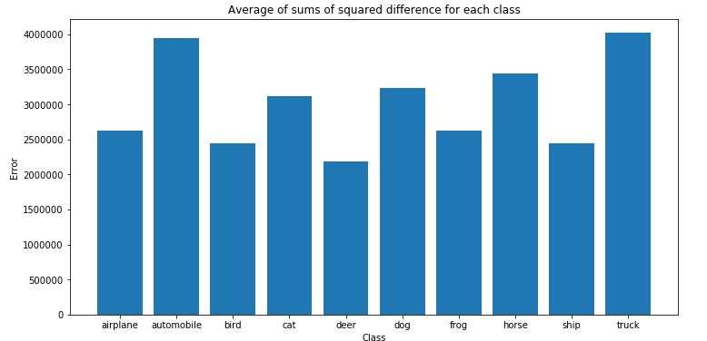

**Page 3: The 2D scatter plot obtained after performing principal coordinate analysis using Euclidean distance.**

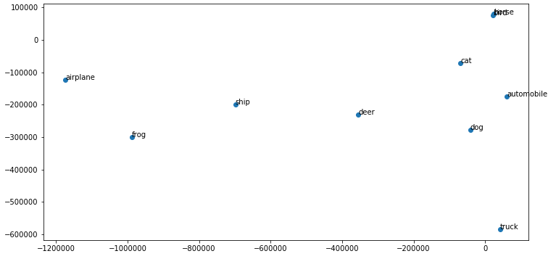

**Page 4: The 2D scatter plot obtained after performing principal coordinate analysis using the similarity metric in part C.**